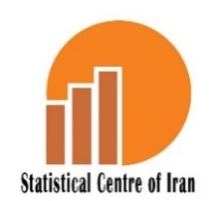

A Selection of Labour Force Survey Results
Autumn, the Year 1404 (23 September -21 December)

Introduction
The pair of concepts of employment and unemployment are so fundamental to national economies that any increase in the employment rate, which signifies a decrease in unemployment, is considered an indicator of national development. The unemployment rate is used to evaluate the national economic conditions. The information on the nation's market is gathered through the “Household Employment and Unemployment Characteristics Survey (HEUCS)” as of the year 1376. However, in order to enhance the quality of the HEUCS and align it with international concepts, particularly those of the ILO, the survey plan was revised to implement the current plan called the “Labour Force Survey”. The “Labour Force Survey” was first conducted in the year 1384 and has since been regularly conducted in the middle month of every season.
The “Labour Force Survey” is conducted to obtain information on the structure and current status of the labour force, as well as its changes. This objective is achieved through the estimation of “seasonal and annual labour force indicators at both national and provincial levels”, “the estimation of the annual number of the labour force at both national and provincial levels”, “the estimation of seasonal and annual changes in labour force indicators at national and provincial levels”, and “the estimation of annual changes in labour force indicators at provincial levels”.

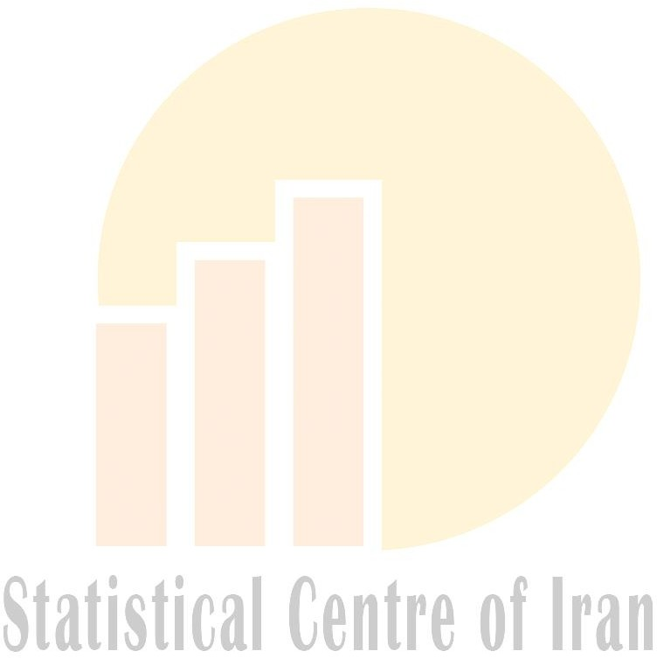
The population covered in this survey includes people who, according to the definition, are members of private settled households or collective households in rural or urban areas. Therefore, members of private, unsettled households and institutional households are not included in this survey. The method used for conducting this survey is a two-stage stratified cluster sampling method. In addition to estimating current levels, changes are also estimated. Therefore, rotation sampling is used. Rotation sampling can provide the best estimate of current levels and changes by fixing some sample units between two quarters of the survey and changing the remaining units. With respect to the aim of the survey, the selected rotation pattern for this survey is a “2-2-2” pattern. This means that during the Master Sample period, each sample household is enumerated four times. Accordingly, that sample household is in the sample for two successive quarters and then excluded from the sample. Note that the optimal implementation of rotational sampling requires using a master sample. The master sample refers to the sample that can be used to select sub-samples to satisfy the needs of several surveys or rounds of a survey. In continuous surveys, utilizing a master sample enhances cost-effectiveness and allows for improved control of field operations and sampling overlap across various survey rounds. The sampling frame for the first stage, starting in spring, the year 1397, is the fourth master sample from household surveys based on the results of the 2016 National Population and Housing Census. The master sample includes the sampling units (clusters) of the first stage. Each cluster contains one block/village, part of a large block/village, or in some cases a combination of some small blocks/villages which were created from the 2016 National Population and Housing Census. With respect to the changes in population and housing units in urban areas and in order to prepare an appropriate and updated frame in urban areas, some households were listed within the master sample clusters in the winter of the year 1404, however, due to limited changes in population and housing units in rural areas, no listing was made in rural areas.
To conduct the Labour Force Survey for each quarter in the year 1404, 60,648 households were enumerated in both urban and rural areas throughout the country. After releasing the preliminary results of this survey, the SCI disseminates the detailed results at annual and quarterly intervals. Users, researchers, and planners can access the results of this survey for the autumn of the year 1404, and download them in Excel format from www.amar.org.ir in the Month of Bahman of the year 1404.

This survey's target population includes private settled households and collective households in urban and rural areas.

Data for this survey were collected through face-to-face interviews. The enumerator interviewed the most informed member of each household to complete the household questionnaire. Additionally, the enumerator interviewed every household member aged 10 and over to complete the individual questionnaire.
It is important to note that the definitions and concepts used in the Labour Force Survey were developed and implemented based on the 13th Resolution of the International Conference of Labour Statisticians (ICLS13).
It should be noted that since the spring of the year 1397, a 95% confidence interval has been provided for the unemployment rate indicator in the published survey results. From a statistical methodology standpoint, this confidence interval implies that if multiple samples were drawn from the target population using the same sampling method, and a confidence interval was calculated for each, we would expect 95% of those intervals to contain the true unemployment rate of the population.
It is worth noting that, based on recent studies and evolving social patterns regarding the age of entry into the labour market across various countries, a minimum age of 15 has been adopted for evaluating key labour market indicators. Following similar developments in our country, major labour market indicators have been calculated and reported for the population aged 15 and over starting from the spring of the year 1398.

Findings
This report summarizes the results of an autumn survey conducted in the year 1404, focusing on key indicators of the labour market and its changes compared to the same season of the last year (autumn, the year 1403). The findings are presented in Table 1. Additionally, Table 2 provides a breakdown of the major labour market indicators by province. Figure 1 illustrates an overview of the major labour market indicators in autumn of the year 1404 at a glance.

Figure 1. Major Indicators of Labour Market in Autumn, the Year 1404 (the figures are at thousand persons)

A review of the economic participation rate (activity rate) for the population aged 15 and over reveals that 40.7% of the working-age population was economically active; meaning they were either employed or unemployed. Additionally, the results indicate that the economic participation rate was lower among women than men, and lower in urban areas relative to rural areas. Analysis of the trend in the national economic participation rate shows that this indicator decreased by 0.5 percentage points compared to the same season of the previous year (autumn of the year 1403). Furthermore, the employment-to-population ratio for those aged 15 and over indicates that 37.5% of the working-age population was employed. This indicator was higher for men and rural areas compared to women and urban areas.

TABLE 1. MAJOR LABOUR MARKET INDICATORS AND THEIR CHANGES BY SEX, URBAN AND RURAL AREAS; AUTUMN, THE YEAR 1404 COMPARED TO THE AUTUMN, THE YEAR 1403
(number person-rate, share and ratio: percent)
Labour force indicators |  | Total country |  |  | Male |  |  | Female
 |  | Autumn, the year 1404 | Autumn, the year 1403 | Changes | Autumn, the year 1404 | Autumn, the year 1403 | Changes | Autumn, the year 1404 | Autumn, the year 1403 | Changes
Population aged 15 and over¹ | Number | 66250214 | 65435022 | 815192 | 33059260 | 32662093 | 397167 | 33190954 | 32772929 | 418025
Economic participation of population aged 15 and over | Rate | 40.7 | 41.2 | -0.5 | 67.8 | 68.0 | -0.2 | 13.6 | 14.5 | -0.9
Economic participation of population aged 15 and over | Number | 26949932 | 26935072 | 14860 | 22421980 | 22194775 | 227205 | 4527953 | 4740296 | -212343
Economically inactive population aged 15 and over | Number | 39300282 | 38499950 | 800332 | 10637280 | 10467318 | 169962 | 28663001 | 28032632 | 630369
Employment of population aged 15 and over | Ratio | 37.5 | 38.2 | -0.7 | 63.7 | 64.0 | -0.3 | 11.5 | 12.5 | -1.0
Employment of population aged 15 and over | Number | 24856634 | 24983452 | -126818 | 21053303 | 20892491 | 160812 | 3803331 | 4090961 | -287630
Unemployment of population aged 15 and over | Rate | 7.8 | 7.2 | 0.6 | 6.1 | 5.9 | 0.2 | 16.0 | 13.7 | 2.3
Unemployment of population aged 15 and over | Number | 2093298 | 1951620 | 141678 | 1368676 | 1302284 | 66392 | 724622 | 649335 | 75287
Unemployment of population aged 15-24 | Rate | 21.5 | 20.2 | 1.3 | 18.2 | 18.2 | 0.0 | 35.2 | 27.8 | 7.4
Unemployment of population aged 15-24 | Number | 587099 | 533790 | 53309 | 400667 | 383635 | 17032 | 186433 | 150155 | 36278
Unemployment of population aged 18-35 | Rate | 15.9 | 14.3 | 1.6 | 12.6 | 11.6 | 1.0 | 27.9 | 24.1 | 3.8
Unemployment of population aged 18-35 | Number | 1453301 | 1373969 | 79332 | 902675 | 868641 | 34034 | 550626 | 505328 | 45298
Unemployment of the population aged 15 and over graduated from higher education institutes | Rate | 10.7 | 11.1 | -0.4 | 6.9 | 7.4 | -0.5 | 19.0 | 19.0 | 0.0
 | Number | 821162 | 840612 | -19450 | 369293 | 381080 | -11787 | 451869 | 459532 | -7663
Employment in agriculture sector | Share | 13.6 | 13.7 | -0.1 | 13.9 | 14.2 | -0.3 | 12.1 | 11.4 | 0.7
Employment in agriculture sector | Number | 3377452 | 3433585 | -56133 | 2917547 | 2968689 | -51142 | 459905 | 464896 | -4991
Employment in manufacturing sector | Share | 33.2 | 33.5 | -0.3 | 34.9 | 35.2 | -0.3 | 23.9 | 25.2 | -1.3
Employment in manufacturing sector | Number | 8254837 | 8375447 | -120610 | 7345936 | 7344784 | 1152 | 908902 | 1030662 | -121760
Employment in services sector | Share | 53.2 | 52.7 | 0.5 | 51.2 | 50.6 | 0.6 | 64.0 | 63.4 | 0.6
Employment in services sector | Number | 13217689 | 13165424 | 52265 | 10784175 | 10570568 | 213607 | 2433514 | 2594856 | -161342
Underemployment | Share | 7.9 | 7.4 | 0.5 | 8.4 | 8.0 | 0.4 | 4.9 | 4.2 | 0.7
Underemployment | Number | 1961011 | 1841026 | 119985 | 1773390 | 1671119 | 102271 | 187621 | 169907 | 17714
The share of the unemployed (aged 15 and over) higher education graduates out of the total unemployed population | Share | 39.2 | 43.1 | -3.9 | 27.0 | 29.3 | -2.3 | 62.4 | 70.8 | -8.4
The share of the employed (aged 15 and over) higher education graduates out of the total employed population | Share | 27.7 | 26.9 | 0.8 | 23.5 | 22.8 | 0.7 | 50.6 | 47.8 | 2.8
- The difference between the total employed persons and the sum of the employed persons in the three sectors is due to the unreported major sectors of economic activity.
- The difference is due to rounding.
1. The target population of the labour force survey is individuals of working age from private settled and collective households in urban and rural areas.

TABLE 1. MAJOR LABOUR MARKET INDICATORS AND THEIR CHANGES BY SEX, URBAN AND RURAL AREAS; AUTUMN, THE YEAR 1404 COMPARED TO THE AUTUMN, THE YEAR 1403 (continued) (number person, rate, share and ratio: percent)
Labour force indicators |  | Urban areas |  |  | Rural areas
 |  | Autumn, the year 1404 | Autumn, the year 1403 | Changes | Autumn, the year 1404 | Autumn, the year 1403 | Changes
Population aged 15 and over¹ | Number | 51875693 | 51027969 | 847724 | 14374521 | 14407053 | -32532
Economic participation of population aged 15 and over | Rate | 40.3 | 40.8 | -0.5 | 42.2 | 42.6 | -0.4
Economic participation of population aged 15 and over | Number | 20881272 | 20802819 | 78453 | 6068660 | 6132253 | -63593
Economically inactive population aged 15 and over | Number | 30994421 | 30225150 | 769271 | 8305861 | 8274800 | 31061
Employment of population aged 15 and over | Ratio | 36.8 | 37.6 | -0.8 | 39.9 | 40.3 | -0.4
Employment of population aged 15 and over | Number | 19115268 | 19172949 | -57681 | 5741366 | 5810503 | -69137
Unemployment of population aged 15 and over | Rate | 8.5 | 7.8 | 0.7 | 5.4 | 5.2 | 0.2
Unemployment of population aged 15 and over | Number | 1766004 | 1629870 | 136134 | 327294 | 321750 | 5544
Unemployment of population aged 15-24 | Rate | 23.1 | 21.3 | 1.8 | 16.8 | 17.0 | -0.2
Unemployment of population aged 15-24 | Number | 466688 | 421156 | 45532 | 120412 | 112634 | 7778
Unemployment of population aged 18-35 | Rate | 16.9 | 15.1 | 1.8 | 12.0 | 11.3 | 0.7
Unemployment of population aged 18-35 | Number | 1229643 | 1151439 | 78204 | 223659 | 222529 | 1130
Unemployment of the population aged 15 and over graduated from higher education institutes | Rate | 10.5 | 10.8 | -0.3 | 13.2 | 14.4 | -1.2
 | Number | 742999 | 751124 | -8125 | 78163 | 89487 | -11324
Employment in agriculture sector | Share | 5.6 | 5.6 | 0.0 | 40.1 | 40.5 | -0.4
Employment in agriculture sector | Number | 1072406 | 1082908 | -10502 | 2305046 | 2350677 | -45631
Employment in manufacturing sector | Share | 34.2 | 34.4 | -0.2 | 30.0 | 30.7 | -0.7
Employment in manufacturing sector | Number | 6531272 | 6590277 | -59005 | 1723565 | 1785169 | -61604
Employment in services sector | Share | 60.2 | 59.9 | 0.3 | 29.8 | 28.8 | 1.0
Employment in services sector | Number | 11504934 | 11491769 | 13165 | 1712755 | 1673655 | 39100
Underemployment | Share | 6.7 | 6.0 | 0.7 | 11.8 | 11.7 | 0.1
Underemployment | Number | 1281820 | 1158890 | 122930 | 679191 | 682136 | -2945
The share of the unemployed (aged 15 and over) higher education graduates out of the total unemployed population | Share | 42.1 | 46.1 | -4.0 | 23.9 | 27.8 | -3.9
The share of the employed (aged 15 and over) higher education graduates out of the total employed population | Share | 33.3 | 32.2 | 1.1 | 9.0 | 9.2 | -0.2
- The difference between the total employed persons and the sum of the employed persons in the three sectors is due to the unreported major sectors of economic activity.
- The difference is due to rounding.
1. The target population of the labour force survey is individuals of working age from private settled and collective households in urban and rural areas.

A review of employment in major economic sectors indicates that the services sector holds the biggest share of employment with 53.2% of the total, followed by the industrial sector with 33.2% and the agriculture sector with 13.6%. In the autumn of the year 1404, the contribution of the employed people to the services sector increased by 0.5 percentage points and the contribution of the employed people to the industrial and agriculture sectors has decreased by 0.3 and 0.1 percentage points respectively in comparison with the last corresponding season (autumn, the year 1403).

A review of the unemployment rate among the population aged 15 and over indicates that 7.8% of the economically active population is unemployed. Furthermore, based on a 95% confidence interval, the total national unemployment rate ranges between 7.4% and 8.1%, with a point estimate of 7.8%. This means that, with a 95% confidence interval, this range reflects the true national unemployment rate. The results show that the unemployment rate is higher for women and in urban areas compared to men and rural areas. An analysis of the trend in this indicator at the national level reveals a 0.6% increase compared to the same season last year (autumn of the year 1403).

The unemployment rate for youths aged 15-24 shows that 21.5 percent of the economically active population in this age group is unemployed. was higher among women and in urban areas than for men and rural areas. Additionally, an analysis of the trend in the national unemployment rate for this age group reveals an increase of 1.3 percentage points compared to the same period of the last year.

The unemployment rate among youths aged 18 to 35 indicates that 15.9 percent of the active population in this age group was unemployed. This rate was higher for women and in urban areas than for men and rural areas. A review of the trends for this group shows that this rate has increased by 1.6 percentage points compared to the last corresponding season (autumn of the year 1403).

A review of the unemployment rate among higher education graduates aged 15 and over indicates that 10.7 percent of the active population in this group was unemployed. This rate was higher for women than for men, and higher in rural areas compared to urban areas. Furthermore, trend analysis shows that this rate decreased by 0.4 percentage points in the autumn of the year 1404 compared to the same season last year (autumn of the year 1403).

The underemployment share indicates that 7.9 percent of the employed population aged 15 and over was underemployed. This indicator was higher for men and in rural areas than for women and in urban areas. In the autumn of the year 1404, the underemployment share increased by 0.5 percentage points compared to the same season last year (autumn of the year 1403).
The study of the share of employed persons aged 15 and over, with usual working hours of 49 hours and over, shows that 37.9% of the employed typically work 49 hours or more per week. This indicator, which is one of the measures of decent work, demonstrates that a significant portion of the employed workforce works beyond the standard hours. This indicator experienced a 0.6 percentage point decrease compared to the last corresponding season (autumn of the year 1403).
In the autumn of the year 1404, the share of unemployed higher education graduates out of the total unemployed population was 39.2 percent. This indicator is higher for women and urban areas than for men and rural areas. A review of the changes shows that this indicator experienced a 3.9 percentage point decrease compared to the last corresponding season ((autumn of the year 1403).

In the autumn of the year 1404, the share of employed higher education graduates out of the total employed population was 27.7 percent. This indicator is also higher for women and urban areas than for men and rural areas. A review of the changes shows that this indicator increased by 0.8 percentage points over the last corresponding season (autumn of the year 1403).

Year

Table 2 shows some major labour market indicators for the population aged 15 and over in the autumn, the year 1404 compared to the last corresponding season (autumn of the year 1403).

TABLE 2- SOME MAJOR LABOUR MARKET INDICATORS FOR THE POPULATION AGED 15 AND
OVER IN THE AUTUMN, THE YEAR 1404 COMPARED TO THE LAST CORRESPONDING
SEASON (AUTUMN, THE YEAR 1403) (percent)
Province | Economic participation rate |  | Employment ratio |  | Unemployment rate
Province | Autumn,  the year 1404 | Autumn,  the year 1403 | Autumn,  the year 1404 | Autumn,  the year 1403 | Autumn, the year 1404 |  | Autumn, the year 1403
 |  |  |  |  | Point-to-point estimation | The confidence interval (95%) | Autumn, the year 1403
Total country | 40.7 | 41.2 | 37.5 | 38.2 | 7.8 | (7.4-8.1) | 7.2
East Azarbayejan | 41.4 | 41.2 | 38.5 | 38.5 | 7.1 | (5.7-8.4) | 6.5
West Azarbayejan | 40.4 | 41.3 | 38.2 | 38.4 | 5.6 | (4.4-6.9) | 7.0
Ardebil | 49.0 | 45.2 | 44.8 | 40.6 | 8.5 | (6.6-10.5) | 10.1
Esfahan | 40.8 | 40.2 | 37.0 | 37.3 | 9.1 | (7.7-10.6) | 7.1
Alborz | 39.7 | 39.5 | 36.9 | 36.4 | 7.1 | (5.5-8.7) | 7.9
Ilam | 32.4 | 31.4 | 29.5 | 29.7 | 8.9 | (6.8-11.1) | 5.5
Bushehr | 38.8 | 39.8 | 36.4 | 36.8 | 6.1 | (4.5-7.7) | 7.5
Tehran | 40.2 | 40.5 | 37.3 | 38.7 | 7.3 | (6-8.6) | 4.5
Chaharmahal & Bakhtiyari | 41.8 | 43.8 | 39.2 | 40.5 | 6.3 | (4.9-7.6) | 7.4
South Khorasan | 41.4 | 40.9 | 39.8 | 39.0 | 3.7 | (2.6-4.8) | 4.7
Khorasan-e-Razavi | 43.8 | 46.4 | 40.4 | 43.3 | 7.7 | (6.2-9.2) | 6.6
North Khorasan | 44.6 | 45.3 | 40.7 | 41.3 | 8.7 | (10.5-7.0) | 8.8
Khuzestan | 39.5 | 40.2 | 34.8 | 35.4 | 12.0 | (10.2-13.9) | 11.9
Zanjan | 50.1 | 51.6 | 46.1 | 48.1 | 8.0 | (6.2-9.7) | 6.8
Semnan | 38.2 | 38.3 | 35.7 | 36.1 | 6.5 | (4.6-8.4) | 5.8
Sistan & Baluchestan | 32.3 | 36.2 | 28.7 | 31.7 | 11.2 | (8.5-13.9) | 12.5
Fars | 38.0 | 37.5 | 35.6 | 35.3 | 6.4 | (7.8-5.0) | 5.7
Qazvin | 44.3 | 43.3 | 40.8 | 40.8 | 7.9 | (6.3-9.5) | 5.8
Qom | 38.4 | 39.9 | 35.6 | 36.8 | 7.4 | (5.7-9.1) | 7.8
Kordestan | 41.3 | 43.3 | 38.2 | 39.3 | 7.4 | (5.4-9.4) | 9.3
Kerman | 38.4 | 39.8 | 35.5 | 36.2 | 7.6 | (5.9-9.3) | 9.0
Kermanshah | 41.8 | 43.4 | 37.2 | 38.3 | 11.0 | (8.1-13.9) | 11.8
Kohgiluyeh & Boyerahmad | 31.7 | 33.7 | 29.9 | 30.4 | 5.9 | (4.2-7.6) | 9.8
Golestan | 40.8 | 39.4 | 36.1 | 35.5 | 11.5 | (13.9-9.0) | 9.9
Gilan | 41.4 | 43.4 | 38.2 | 40.1 | 7.7 | (5.9-9.5) | 7.7
Lorestan | 40.3 | 41.7 | 37.3 | 36.9 | 7.5 | (9.0-6.0) | 11.5
Mazandaran | 45.0 | 43.9 | 42.3 | 41.9 | 6.0 | (4.4-7.6) | 4.7
Markazi | 39.6 | 36.3 | 37.6 | 34.1 | 5.2 | (3.9-6.5) | 5.9
Hormozgan | 39.8 | 40.8 | 37.2 | 37.9 | 6.7 | (8.4-5.0) | 7.1
Hamedan | 41.8 | 42.8 | 38.5 | 39.2 | 8.1 | (6.3-9.8) | 8.2
Yazd | 43.3 | 41.7 | 40.4 | 39.5 | 6.7 | (4.6-8.8) | 5.5

ECONOMIC PARTICIPATION RATE FOR THE POPULATION AGED 15 AND OVER
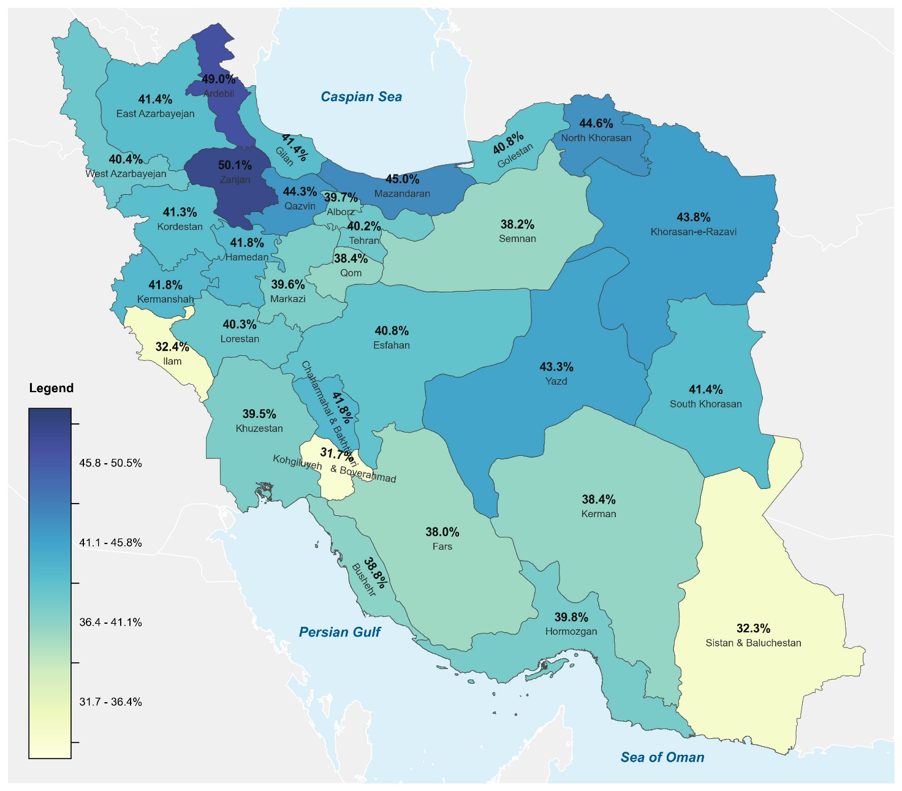

UNEMPLOYMENT RATE FOR THE POPULATION AGED 15 AND OVER
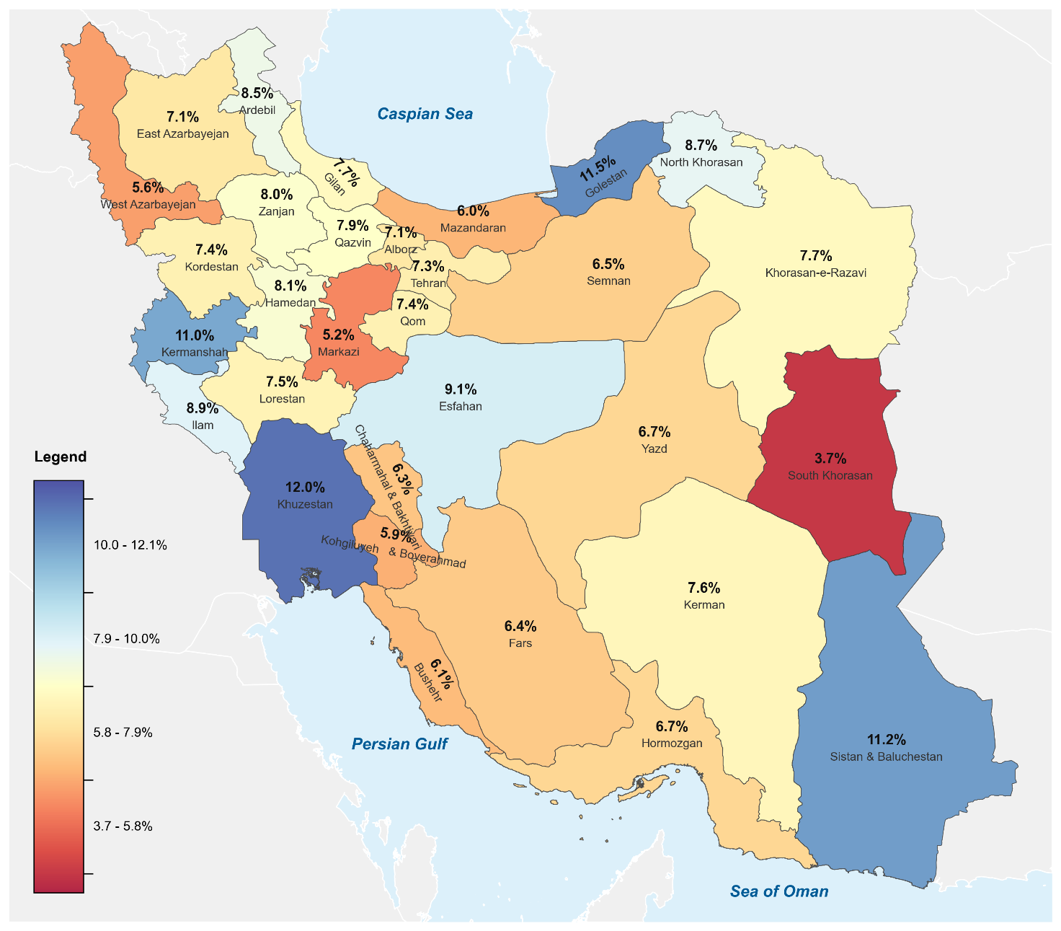

Definitions and concepts
The Statistical Centre of Iran employs new international definitions and concepts based on the ICLS 1982 for measuring employment and unemployment in the Labour Force Survey.
Work: This key term is used to determine the status of the economic activity of the people. The term “work” refers to the group of economic activities (mentally or physically) which are done for earning income (cash or in-kind) and its objective is to produce goods or services. Generally, the people who work are divided into two groups: self-employed, who work for themselves, and wage and salary earners, who earn money for the work they do.
Statistical period (reference week): Refers to the second or third calendar week (Saturday to Friday) of the middle month of each season.
Employed: All people aged 15 or over who, according to the definition of work, have worked for at least one hour during the reference week or have temporarily left their job for one reason or another, are reckoned as employed. Persons who, without receiving any remuneration, work for a member of their household that is a relative (unpaid family workers); trainees who perform an activity in relation to the activity of the institute for apprenticeships during the training period, namely, they directly contribute to the production of goods or services, their activity is considered “work”; students who have worked during the reference week, according to the definition of work; and all people who are serving as a permanent and temporary cadre in the armed forces (armed forces, cadre personnel, soldiers, commissioned officers, non-commissioned officers of the military forces and the police) are considered employed.
Unemployed: The unemployed are all people aged 15 or over who have the following three criteria together:
- have no job during the reference week (not engaged in a wage/salary job or
self-employment),
- have been seeking job during the reference week and the preceding three weeks (have taken specific steps to seek paid employment or self-employment),
- are available to work during the reference week or the following week (available for a wage/salary employment or self-employment). All people who, because of expecting to start a job in future or return to their former job, have not been seeking a job, but have had no job and have been available to work - are also considered unemployed.
Labour force (active population): is the sum of persons in employment plus persons in unemployment.
Underemployment: The underemployed people are all employed people who have been present in or temporarily absent from the workplace and have worked less than 44 hours during the reference week due to economic reasons such as work recession, not finding a job with more hours, or non-work season, but have been willing and ready to do more work in the reference week.

Indicators
Economic participation rate (Economic activity rate)
The ratio of the active population (employed & unemployed) to the working age population multiplied by 100.
Economically active population aged 15 and over
Economic participation rate = × 100
Population aged 15 and over

Employment ratio: The ratio of the employed population to the total population at working age, multiplied by 100.
Employed population aged 15 and over
Employment ratio = × 100
Population aged 15 and over

Unemployment rate
The ratio of the unemployed population to the active population (employed & unemployed) multiplied by 100.
Unemployed population aged 15 and over
Unemployment rate = × 100
Active population aged 15 and over
Employment rate
The ratio of the employed population to the active population (employed & unemployed) multiplied by 100.
Employed population aged 15 and over
Employment rate = × 100 = 100 - unemployment rate
Active population aged 15 and over
Unemployment rate of the population aged 15-24
The ratio of the unemployed population aged 15-24 to the economically active population aged 15-24 multiplied by 100.
Unemployed population aged 15-24
Unemployment rate aged 15-24 = ×100
Economically active population aged 15-24

Unemployment rate of the population aged 18-35
The ratio of the unemployed population aged 18-35 to the economically active population aged 18-35 multiplied by 100.
Unemployed population aged 18-35
Unemployment rate aged 18-35 = ×100
Economically active population aged 18-35
Unemployment rate of higher education graduates
The ratio of unemployed higher education graduates to active higher education graduates multiplied by 100.
Unemployed higher education graduates
Unemployment rate of higher education graduates = ×100
Economically active higher education graduates

Share of unemployed higher education graduates aged 15 and over
The ratio of unemployed higher education graduates to the total unemployed population aged 15 and over multiplied by 100.
Unemployed higher education graduates aged 15 and over
Share of unemployed higher education graduates aged 15 and over = ×100
Unemployed population aged 15 and over

Share of employed higher education graduates aged 15 and over
The ratio of employed higher education graduates to the total employed population aged 15 and over multiplied by 100.
Employed higher education graduates aged 15 and over
×100
Share of employed higher education graduates aged 15 and over =
Total employed population aged 15 and over
Underemployment share of population aged 15 and over
The ratio of the underemployed population aged 15 and over to the employed population aged 15 and over multiplied by 100.
Underemployed population aged 15 and over
Underemployment share of population aged 15 and over = × 100
Employed population aged 15 and over

1. It is the Iranian year which usually begins on the day of 21 March of Gregorian calendar. To find the corresponding year of Gregorian calendar, add 621 or 622 (depending on the time of the year) to a solar Hijri year. For example, the corresponding year of the year 1404 in Gregorian calendar is (21 March 2025-20 March 2026). Iranian seasons and their equivalent in Gregorian calendar Spring (21 March-21 June) Summer (22 June - 22 September) Autumn (23 September -21 December) Winter (22 December - 20 March)
ILO, Thirteenth International Conference of Labour Statisticians (Geneva, 1982).

